**Part C:**

**MS Power Point Exercises:**

Prepare a power point presentation with at least four slides(in each exercise) and picture, chart and other contents for the following. Apply various transition and animations. Slides should be moved automatically and repeatedly.

**Exercise No. 1: About your college.**













**Exercise No. 2: Any visiting place of your choice.**

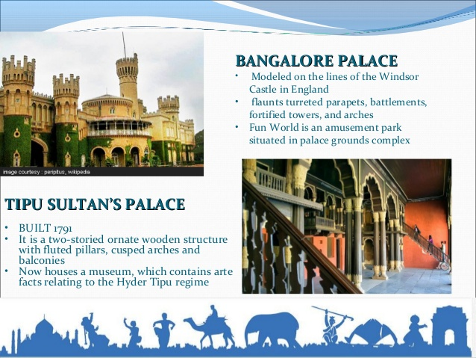 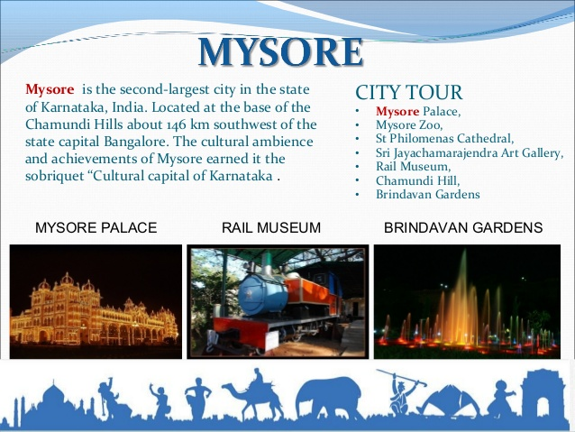

 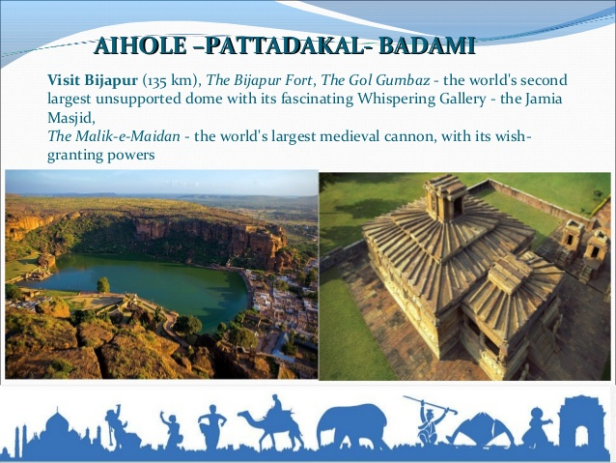

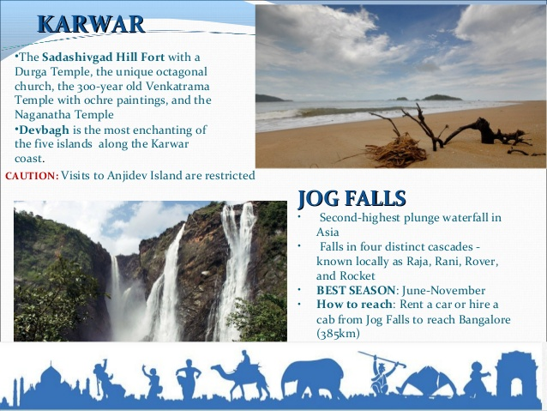 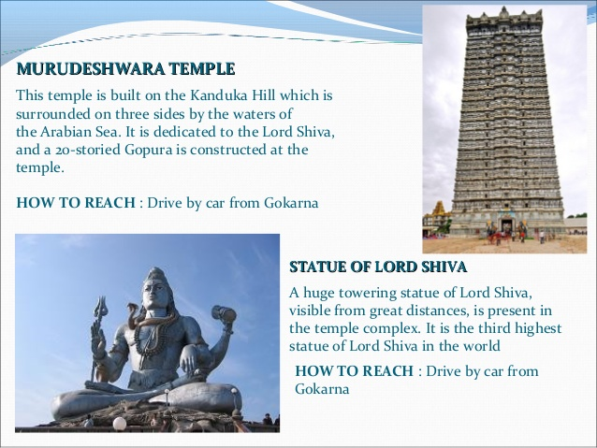

**Exercise No. 3:**

**A simple quiz program. Use diagrams. Use hyperlinks to move to another slide in the presentation to display the result and correct answer. Use at least four questions.**





,















